ANANYA 2024-25

Theme of the Year: Aspire Acquire Inspire
The Department of Mathematics and Statistics organised a talk on “Artificial Intelligence and Data Analytics,” held on 13th December 2024 at the Convention Centre. The session, presented by Mr. Rahul Kowshik, a logistics analyst at Tetra Pak, focused on the critical role of AI and data analytics in optimizing supply chain management. He introduced key elements of supply chain management and explained how AI-driven technologies like Enterprise Resource Planning, Robotics, and Data Analytics are integrated into business operations. Approximately 20 students participated actively, engaging in discussions about the present impact of AI, its application in companies such as Amazon, and future potential across industries. The talk successfully bridged theoretical knowledge with practical insights, enhancing the students' understanding of AI’s relevance in commerce and technology fields.
The Department of Economics organised a student research seminar Competition titled “United Nations Sustainable Development Goals,” held on 15th January 2025 from 10:00 AM to 12:30 PM at AV Front. This seminar involved full participation from the Economics student body and was judged by Dr. Suchita Krishnaprasad, retired Head of Department from Elphinstone College. Students presented research papers emphasizing the achievements, challenges, and future targets related to the SDGs. The competition aimed to sensitize students on global developmental goals while fostering research aptitude and presentation skills. Papers were assessed on content accuracy and presentation quality, promoting academic rigor and critical engagement with sustainable development issues.
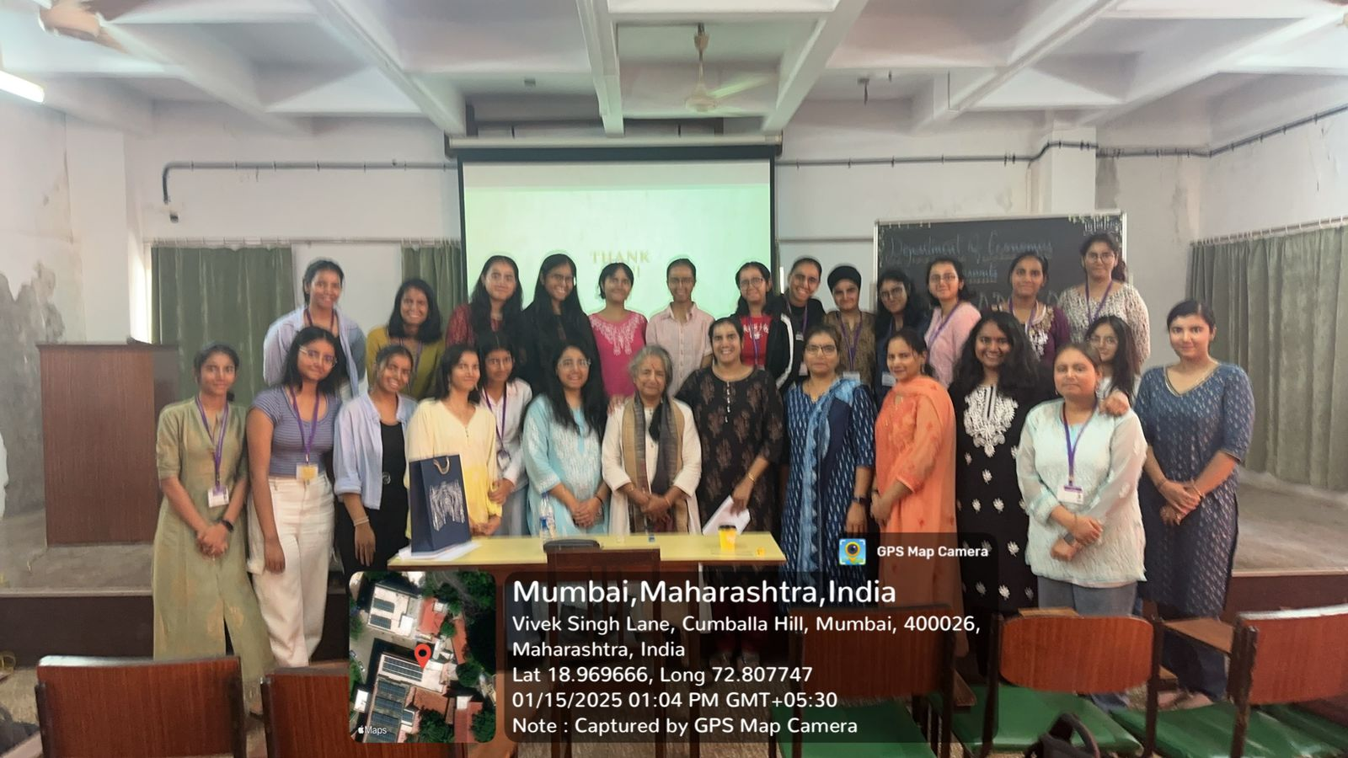
The Department of Philosophy organised a workshop titled “Doodling: Exploring Ethics through Art,” conducted on 29th November 2024 at AV Front with participation from 17 students. This innovative workshop combined ethical inquiry with artistic creativity by asking participants to represent philosophical and ethical concepts through group doodling. Students worked in teams, brainstorming and visually interpreting the themes drawn from prepared chits. After creating their artworks, groups presented their interpretations, which were evaluated by Ms. Simi of the Psychology Department. Prizes were awarded for the most impactful and well-executed artwork. The workshop fostered ethical reflection, collaborative skills, and cross-disciplinary engagement in a creative setting.
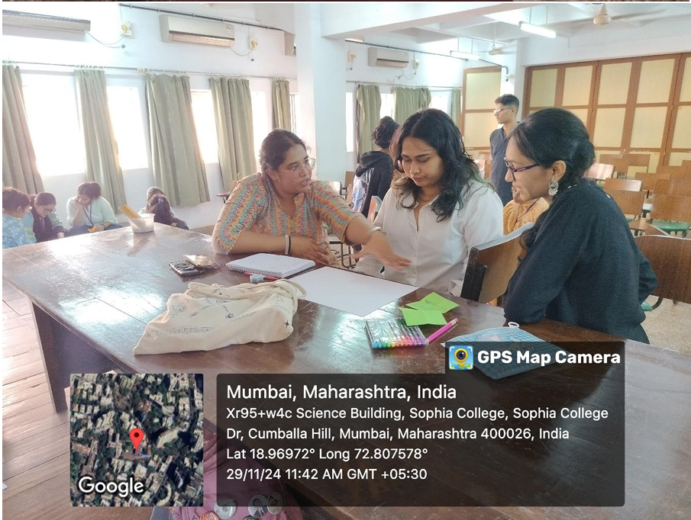
On 24th January 2025, History department organised a RUSA-sponsored Ananya event titled "Navigating in a World as Yet Male-Centric”, delivered by the esteemed speaker, Ms. Armin Wandrewala, a renowned lawyer, and author. She was introduced by Ansari Midhat Fatima, a second-year student. 59 Students of FY, SY and TY attended the event. The session began with Ms. Wandrewala sharing her individual experiences of navigating a career in a traditionally male-dominated field. She highlighted the challenges she faced, such as battling stereotypes and overcoming biases, and provided actionable solutions for tackling such problems.
The Department of English organised a RUSA-supported guest-lecture by Dr Dhrupadi Chattopadhyay titled “Reading the Postmodern Re-Writing of Victorian Novels: Notes from Wide Sargasso Sea” on December 14, 2024 in Room 12. Dr Samrita Sengupta Sinha was the principal coordinator of the event. Ms Jihasa Vachharajani, Ms Nishtha Dev and Dr Elwin Susan John were the co-coordinators for the event. 11 TYBA English S/M students attended the event. Students from the TYBA English S/M class also volunteered to help with the organisational aspect of the event.
As part of the Ananya initiative supported by RUSA, the Department of Sociology organized a creative meme-making competition titled NEP to engage students in critically reflecting on the New Education Policy (NEP) 2020. This activity aimed to encourage students to voice their concerns and critiques of the policy using a popular and accessible digital medium—memes. The competition invited participants to create original memes that highlighted the challenges students face under the NEP, including increased academic pressure, credit overload, confusion around the multiple entry-exit system, and issues with the implementation of the four-year undergraduate program. Memes served as powerful tools to combine humour with critique, enabling students to express complex academic and emotional responses to structural changes in higher education.
The QA department organised Community Kitchen (the 13th Edition of this social outreach initiative was organized during this academic year). The event involved students and staff collaboratively preparing and distributing nutritious meals to marginalized communities. It aimed to promote social responsibility, raise awareness about food security, and foster community service values among participants.
The Department of Political Science at Sophia College for Women organized a guest lecture on December 17, 2024, under the RUSA-supported Ananya Activity. The session, delivered by alumna Ms. Radhe Tambi, a Research Associate at the Centre for Air Power Studies, focused on "Navigating India’s Ties with Major Powers – U.S., Russia, and China”. The lecture highlighted key aspects of India’s foreign relations. Regarding the U.S., it covered deepening defence ties through agreements like BECA, LEMOA, and COMCASA, alongside growing economic and technological collaborations, while addressing challenges from U.S. trade policies affecting India’s strategic autonomy, India-Russia relations centered on their historical friendship, defense and energy cooperation, and the strategic balancing act India performs due to Russia’s alignment with China and repercussions of the Ukraine war. The India-China section discussed border disputes such as Doklam and Galwan Valley, alongside ongoing economic interdependence and counterstrategies such as India’s Act East Policy and QUAD participation.
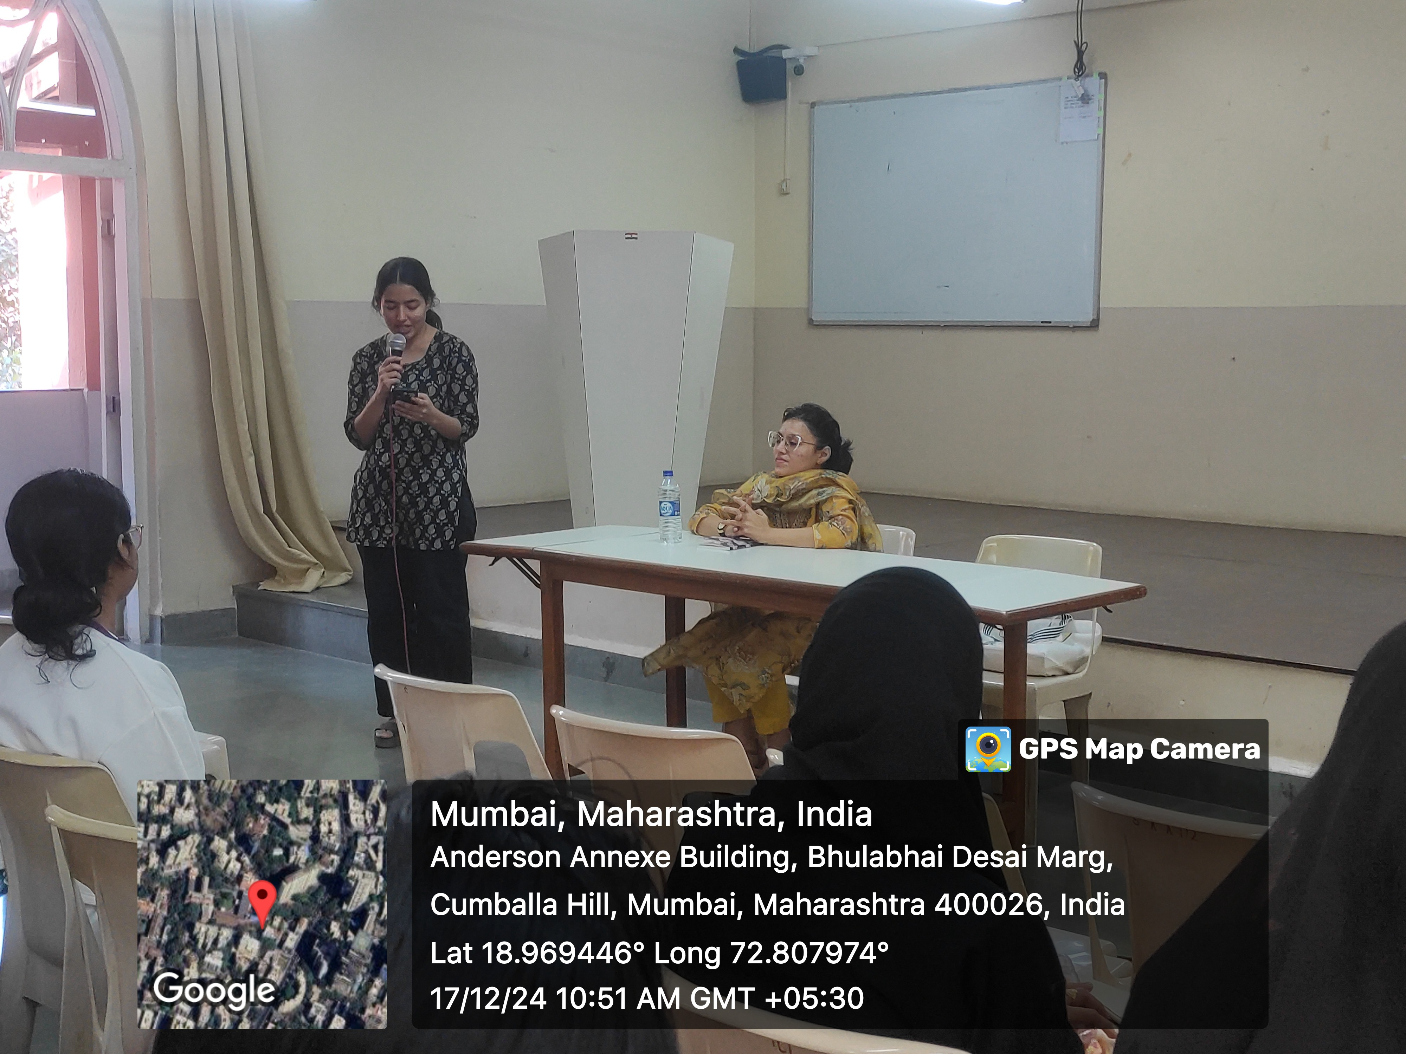
The Department of Psychology Department organised PSYCHNERGY 2024, an intra-collegiate festival held on 19th and 20th December 2024 on campus. Organized by Psychology students and faculty, the festival offered a range of mental health awareness activities, expert talks, workshops, and interactive games designed to develop cognitive skills and promote psychological well-being. The event also featured intellectually stimulating games connected to psychological concepts and included stalls like one from IDP providing consultancy services for study abroad options.
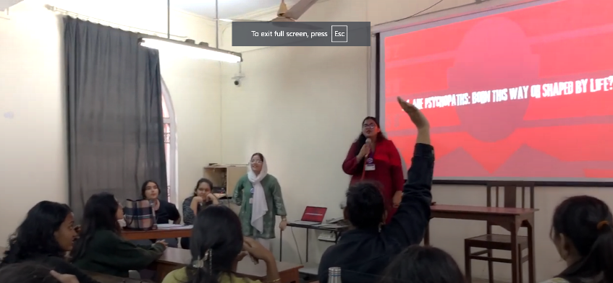
The department of Education organised a karaoke event, held on 3rd January 2025 in the college auditorium. The event provided a platform for students to express themselves through music, showcasing their vocal talents in a lively, informal, and interactive environment. The event drew a large audience, with participants and spectators alike enjoying the power of music to bring people together.
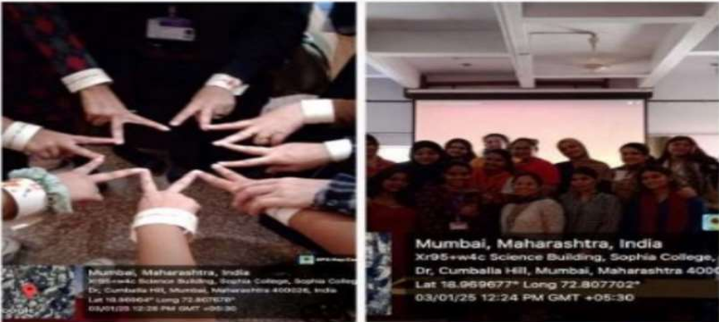
The Department of Microbiology successfully hosted the "Health on Plate" event on December 21, 2024, emphasizing the integration of functional foods into daily diets to promote health. Fifteen students participated, preparing innovative dishes like quinoa tikki, probiotic dahi vada, soya tikkis, ragi idli, and brown rice payasam, each showcasing the nutritional and health benefits of ingredients such as rice bran oil, probiotics, oats, chia seeds, almond, and more. Alongside culinary demonstrations, students created scientifically grounded and visually appealing posters explaining the nutritional content and health-promoting properties of the functional foods. The event was guided by Ms. Sheefa Khan and Ms. Shraddha Prabhu, with Dr. Gitanjali Ganguli serving as the judge. By combining scientific knowledge with culinary creativity, the event fostered a deeper understanding of functional foods' role in wellness while inspiring healthier dietary habits among attendees. This initiative highlighted the department’s commitment to health education through practical application and student engagement.
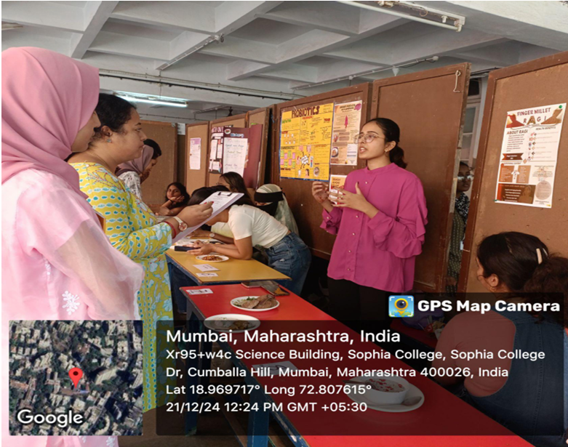
For Ananya 2024-25, the Department of Life Sciences, inspired by the UN’s International Year of Quantum Science and Technology, organised a festival inaugurated with a keynote address by Dr. Phalguni Anand Alladi on Parkinson’s disease, highlighting its pathophysiology, genetic risk factors, and cutting-edge technological interventions like Deep Brain Stimulation and biomarker research. First and second-year students presented posters celebrating women’s contributions to science, fostering gender equity and innovation. The culminating Food Fest, organized by third-year Life Sciences students, showcased sustainable, health-conscious culinary creations such as rice-based chocolate mousse and chicken nachos, emphasizing teamwork and environmental awareness. The festival left attendees motivated, reflecting the power of young minds to shape the future in science and beyond.
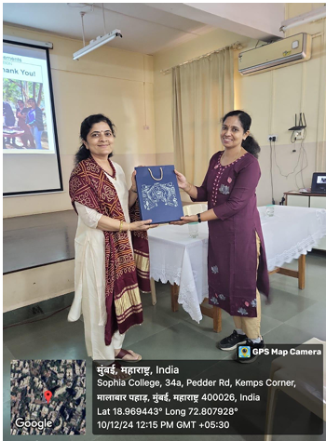
The Department of Chemistry organized a Food Festival named "ZAIKA" as part of the ANANYA 2024-25 event. Held on February 3, 2025, the festival featured 15 stalls run by 27 undergraduate and postgraduate students who prepared and sold homemade food items. The event aimed to inspire students to discover their culinary talents, develop entrepreneurial skills by managing inventory and pricing, and foster team spirit through group collaboration. It also sought to promote social responsibility by donating the profits to a charitable cause. The festival successfully raised money which was donated to Our Lady’s Home, an orphanage in Dadar. Students visited the home, interacted with its residents, and were motivated by the experience to contribute to social causes. The event received positive feedback, boosting participants’ self-confidence and encouraging them to use their culinary abilities for social and economic empowerment. Overall, the festival combined learning, social outreach, and skill development in a meaningful way.
The Zoology department organized a webinar titled "The Junk Food Trap and its Impact on Health" on 25th February 2025, held as an in-house online session with 43 students and 2 staff members. The session aimed to educate participants about the nutritional risks of frequent junk food consumption and to promote healthier eating habits. Dr. Ratnaraje Krishna Thar, a distinguished Public Health Nutritionist with over 30 years of experience, led the interactive session. She detailed how key components of junk food contribute to health issues like obesity, diabetes, and heart disease. Dr. Thar also offered practical, simple alternatives to junk food, motivating students to adopt positive lifestyle changes. The event aligned with the academic theme "Aspire, Acquire, Inspire" and was supported by a RUSA 2.0 grant. Feedback indicated increased awareness and commitment among participants toward healthier diets and positive behavioural change for long-term well-being.
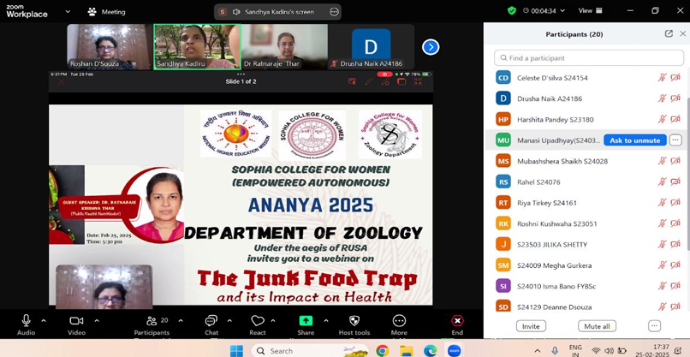
The Department of Physics conducted a poster-making activity on 22nd February 2025 for first-year students, themed "Nuclear Energy – Powering a Sustainable Future." Held on Google Classroom as part of the Ananya activities for 2024–25, this initiative aimed to boost awareness of nuclear energy’s role in creating a cleaner, sustainable world. Students actively engaged by submitting digital posters that creatively illustrated nuclear power's benefits in meeting energy needs while minimizing environmental impact. The activity successfully combined scientific knowledge with artistic expression, fostering creativity, critical thinking, and deeper scientific understanding among participants.
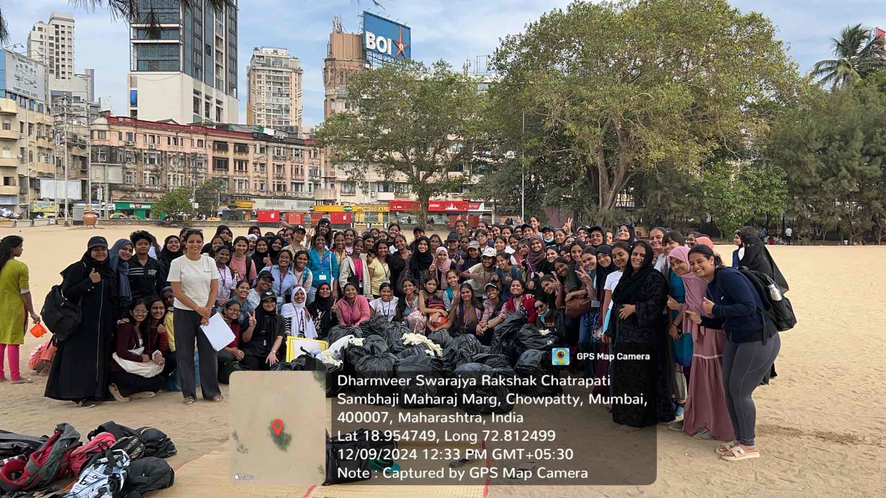
The Department of BSc IT at Sophia College for Women organized a Beach Clean Drive at Girgaon Chowpatty on 9th December 2024, from 10:00 AM to 2:00 PM, as part of the ANANYA initiative. The drive saw active participation from 119 students and 3 staff members. Participants were divided into groups to collect plastic waste, bottles, wrappers, and other non-biodegradable materials using provided safety equipment like gloves and masks. The event aimed to promote environmental responsibility and maintain the beach's natural beauty. It concluded with a reflection session where students shared insights on environmental conservation. The initiative was successful in raising awareness about keeping public spaces clean and sustainable.
On 14th January, 2025, Tuesday in the month of January Hindi Department visited the National Museum of Indian Cinema. Total 31 visited the museum. The Film Division visit to Cumbala hill in Mumbai is a must-visit for film enthusiasts. Located in the heart of Mumbai, the National Museum of Indian Cinema is the main attraction. The museum showcases the rich cinematic history of India, spanning over a century. The visit left students and teachers with a sense of excitement and enthusiasm for the art of filmmaking, as well as a renewed interest in exploring the history and development of Indian cinema.
